Year 10 Chemistry Test

**Multiple Choice Section. Please write on the answer sheet provided. 15 marks.**

1. Which of the following particles are used in determining the position of an element within the periodic table?

a) Protons only.

b) Neutrons only.

c) Electrons only.

d) Protons and electrons.

2. Sodium has 11 electrons. When it is in its ground state, its electron configuration is:

a) 11.

b) 2:8:1.

c) 2:9

d) 10:1.

3. An atom has an electron configuration of 2:8:8:1. What group would it be in?

a) 1.

b) 4.

c) 19.

d) 5.

4. Covalent bonds occur between

a) metal atoms.

b) metal and non - metal atoms.

c) non - metal atoms and other non - metal atoms.

d) lattices.

5. Carbon has an electron configuration of 2:4 and is in group 14. Carbon bonds covalently with hydrogen to form a molecule called methane. Which is the most likely formula for this molecule?

a) CH4

b) CH2

c) CH6

d) CH14

6. Which of the following is **not** true regarding noble gases?

a) They are known as inert gases.

b) They are in group 18.

c) All their atoms have 8 electrons in their outer shell.

d) They are very stable, tending NOT to bond or react with other atoms.

7. Nitrogen is in period 2, group15. Which of the following elements would have properties most similar to nitrogen?

a) Phosphorous.

b) Oxygen.

c) Neon.

d) Sodium.

8. Ions:

a) are negatively charged atoms.

b) are positively charged atoms.

c) are atoms with either a negative or positive charge.

d) none of the above.

9. Haematite, Fe2O3, is not found in the periodic table because

a) it has properties different from the metals in any other group.

b) it is not an element.

c) it is only a recent discovery.

d) its relative atomic mass is too great.

10. Which of the following formula is **incorrect**?

a) K2NO3

b) AgC1

c) Na3PO4

d) Fe(CH3COO)3

11. Bonds that form between a metal and a non-metal are called:

a) metallic bonds

b) ionic bonds

c) covalent bonds

d) james bonds.

12. Which of the following elements is found in all acids?

a) sulphur

b) oxygen

c) hydrogen

d) chlorine.

13. The Law of Conservation of Mass states that during a chemical reaction atoms cannot be created or destroyed. From this Law, it follows that during a chemical reaction, the total mass of the reactants and products:

a) always increases.

b) always decreases.

c) may either decrease or increase.

d) remains the same.

14. The chemical reaction between calcium carbonate and hydrochloric

acid can be represented by the following equation:

CaCO3 + 2HC1 🡪 CaCl2 + CO2 + H20

The carbon dioxide gas (CO2) produced by this reaction can be collected and its volume measured. The following graph represents the volume of carbon dioxide produced over a time period from 0 to 270 seconds when some solid calcium carbonate is reacted with an excess amount of hydrochloric acid.

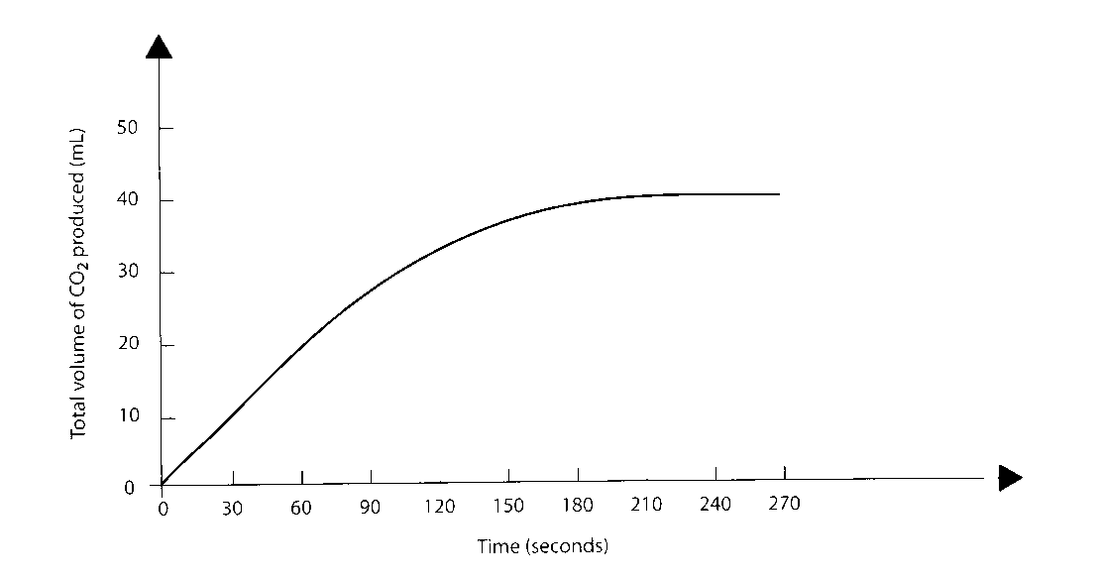

**After how many seconds, from the start of the reaction, had half of the original amount of calcium carbonate reacted?**

a) 60 seconds

b) 90 seconds

c) 105 seconds

d) 150 seconds

15. The term **solubility** is used to describe how well a compound dissolves. Scientists use a solubility table like the one below to determine how soluble or insoluble a compound will be in water.

|  |  |  |
| --- | --- | --- |
| Type of compound | Solubilty | Exceptions |
| Nitrates NO3- | Soluble | None |
| Chlorides Cl-  Bromides Br-  Iodide I- | Soluble | Ag+, Hg+, Pb+ |
| Sulfates SO4-2 | Soluble | Ca2+, Ba2+,Pb2+, Ag+ |
| Carbonates CO3-2 | Insoluble | Li+, Na+, K+, NH3+ |
| Phosphates PO4-3 | Insoluble | Li+, Na+, K+, NH3+ |

Using this table, determine which of the following compounds is insoluble.

a) NaNO3

b) MgCl2

c) K2CO3

d)PbSO4

**Name___________________________________ Please write on this Answer Sheet.**

**SECTION ONE—MULTIPLE CHOICE** (15 marks)

For each question shade the box to indicate your answer. Use only a blue or black pen to shade the boxes. If you make a mistake, place a cross through that square, do not erase or use correction fluid, and shade your new answer. Marks will not be deducted for incorrect answers. No marks will be given if more than one answer is completed for any question.

|  |  |  |  |  |  |  |  |  |  |  |  |  |  |  |
| --- | --- | --- | --- | --- | --- | --- | --- | --- | --- | --- | --- | --- | --- | --- |
| **1** | a | | b | c | d |  | **16** | a | | b | c | | d | |
| **2** | a | | b | c | d |  | **17** | a | | b | c | | d | |
| **3** | a | | b | c | d |  | **18** | a | | b | c | | d | |
| **4** | a | | b | c | d |  | **19** | a | | b | c | | d | |
| **5** | a | | b | c | d |  | **20** | a | | b | c | | d | |
| **6** | a | | b | c | d |  | **21** | a | | b | c | | d | |
| **7** | a | | b | c | d |  | **22** | a | | b | c | | d | |
| **8** | a | | b | c | d |  | **23** | a | | b | c | | d | |
| **9** | a | | b | c | d |  | **24** | a | | b | c | | d | |
| **10** | a | | b | c | d |  | **25** | a | | b | c | | d | |
| **11** | | a | b | c | d |  | **26** | a | b | | | c | | d |
| **12** | | a | b | c | d |  | **27** | a | b | | | c | | d |
| **13** | | a | b | c | d |  | **28** | a | b | | | c | | d |
| **14** | | a | b | c | d |  | **29** | a | b | | | c | | d |
| **15** | | a | b | c | d |  | **30** | a | b | | | c | | d |

Written Section.

1. Choose from the words below to accurately complete the sentences below.

(4 marks)

**Metals gain lose non-metals**

Elements that become positive ions do so because their atoms ______________ electrons. ______________ typically become positive ions. Elements that become negative ions do so because they have a tendency to ______________ electrons. These are______________

**2.** The chemical bonding that holds the atoms of different elements together in compounds can be covalent, ionic or metallic. Each of the different kinds of bonding is characterised by electrons behaving in a particular way.

(4 marks)

**a** Explain the behaviour of the electrons in:

|  |  |
| --- | --- |
| **i**  covalent bonding |  |
|  |  |
|  |  |
| **ii**  ionic bonding |  |
|  |  |
|  |  |

**b** For each substance listed, state the kind of bonding displayed (Covalent, ionic or metallic)

(3 marks)

|  |  |
| --- | --- |
| **i** NaC1 |  |
| **ii** H2O |  |
| **iii** CO2 |  |
| **iv** Fe |  |
| **v** MgO |  |

**vi** Na _____________________________________________________________

4. Write down the chemical formulae for the following: (5 marks)

a. Calcium hydroxide __________________________________

b. Ammonium carbonate_______________________________

c. Potassium phosphate________________________________

d. Calcium chloride____________________________________

e. Aluminium nitrate __________________________________

5. Balance these equations. (5 marks)

a) Mg + HCl → MgCl2 + H2

b) KClO3 → KCl + O2

c) CuO + HNO3 → Cu(NO3)2 + H2O

d) Na2O + H2O → NaOH + O2

e) Fe2O3 + C → Fe + CO2

6. For each of the above reactions state whether it is a single replacement, double replacement, decomposition or synthesis reaction. (5 marks)

a)______________________________

b_______________________________

c)______________________________

d)______________________________

e)______________________________